Bug_id_01
Bug Description:
Email field accepts unlimited characters with no length validation, which can cause UI overflow, backend issues, or invalid email format acceptance.
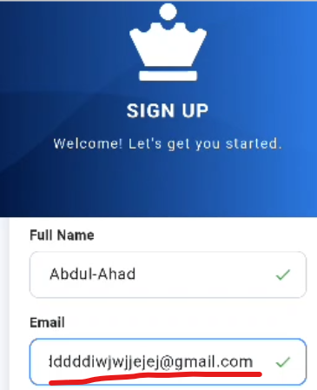

Bug_id_02
Bug Description:
Email field shows both "Invalid email" error and a validation tick (success icon) at the same time when entering invalid data like "jjjjjjjj", which is contradictory.
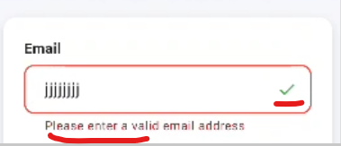

Bug_id_03
Bug Description:
Password field on Sign In page accepts unlimited characters with no maximum length validation, which could lead to UI overflow, backend processing issues, or unexpected behavior during authentication.

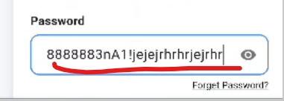

Bug_id_04
Bug Description:
On the Sign In page, the password field accepts spaces (e.g., "hhhh hhBL.") as valid input without showing any validation error. This can lead to incorrect password entries and confusion, as spaces in passwords are typically not allowed or should be explicitly validated.
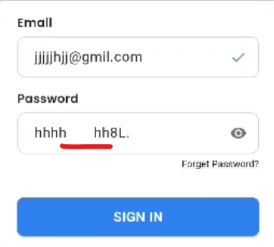

Bug_id_05
Bug Description:
On the Sign In page, entering an invalid email format (e.g., "sh@x.ii") incorrectly shows a validation tick (success icon), misleading the user into thinking the email is valid when it's not. This can cause unnecessary authentication attempts and confusion.

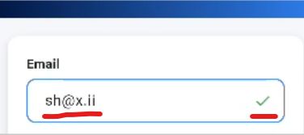

Bug_id_06
Bug Description:
Email field accepts invalid local-part (e.g., "+@gmail.com") and wrongly shows a validation tick, even though email format is incorrect.
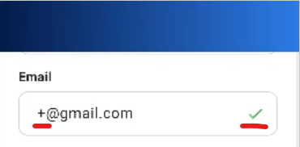

Bug_id_07
Bug Description:
When rotating the phone to horizontal (landscape) mode on the Sign In screen, the UI does not adjust properly — only the logo and heading are visible, while the input fields are squeezed into a small space at the bottom, requiring excessive scrolling and making the form difficult to view or use.

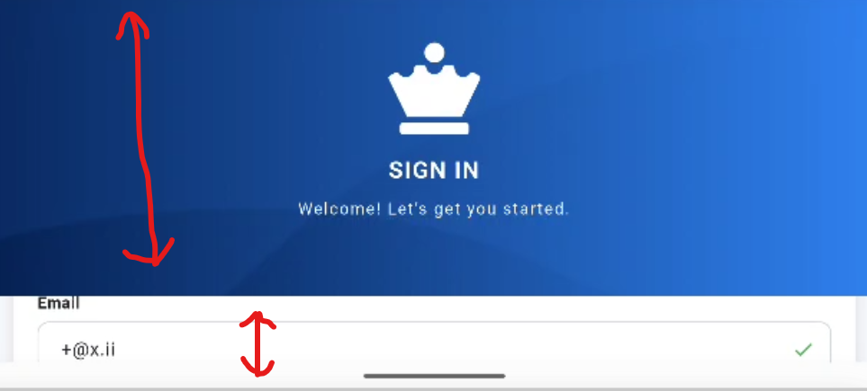

Bug_id_08
Bug Description:
On the Sign In page, the "Forgot Password?" link is displayed in black color, while the "Don't have an account? Signup" link is in blue color. This inconsistent styling can confuse users and reduces UI/UX consistency — both links should follow the same visual design system.

. 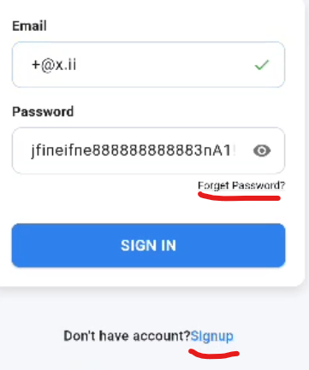

Bug_id_09
Bug Description:
On the Sign In page, the placeholder text inside the Email and Password fields is "email" and "password" (lowercase, generic), while on the Sign Up page it says "Enter your email" and "Enter your password" (full sentence, clearer). This inconsistency in placeholder text across screens creates a poor and unprofessional user experience.
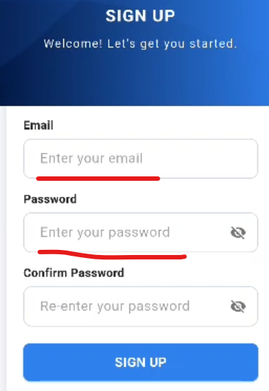
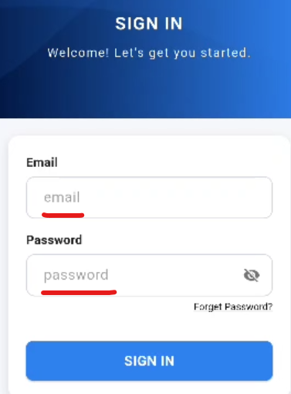

Bug_id_10
Bug Description:
Sign In page lacks a “Remember Me” checkbox, which is a standard usability feature for returning users. This may cause inconvenience as users have to re-enter credentials every time.
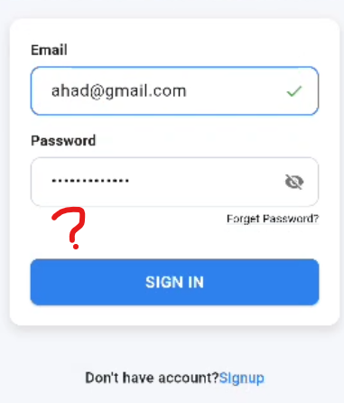
Bug_id_11
Bug Description:
After logging in and closing the app, reopening it within a short time (2 seconds) redirects to the login page again instead of keeping the user logged in and showing the home page. This breaks session persistence and forces unnecessary re-authentication.

